1. Login in to Remote UHBW desktop via UHB remote login
https://uhbpulse.uhbristol.nhs.uk/dana-na/auth/url_GKZ9fq9r1kA9wJ0m/welcome.cgi

2. Open CareFlow EPR (LIVE) 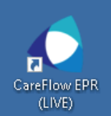
3. Login to Careflow EPR with your personal access 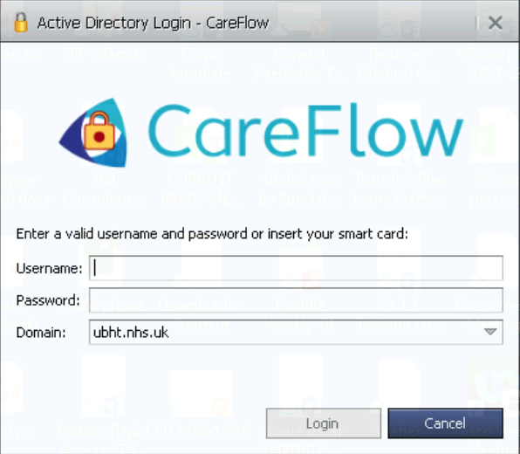
4. Click on Master Patient Index from the drop down menu on the left hand column on the initial screen.
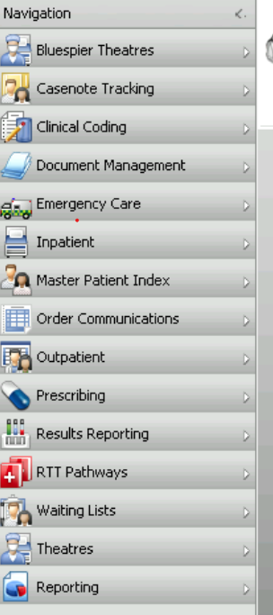

5. Search for your patient through accessing Master Patient Index. Click Search for Patient.

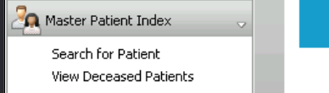
6.Enter patient criteria in yellow box top R hand corner of screen.
Search for patient by entering NHS number (other identifier)
( NOTE if Patient not previously seen in UHBW then ask Administrative team to create a T: number )

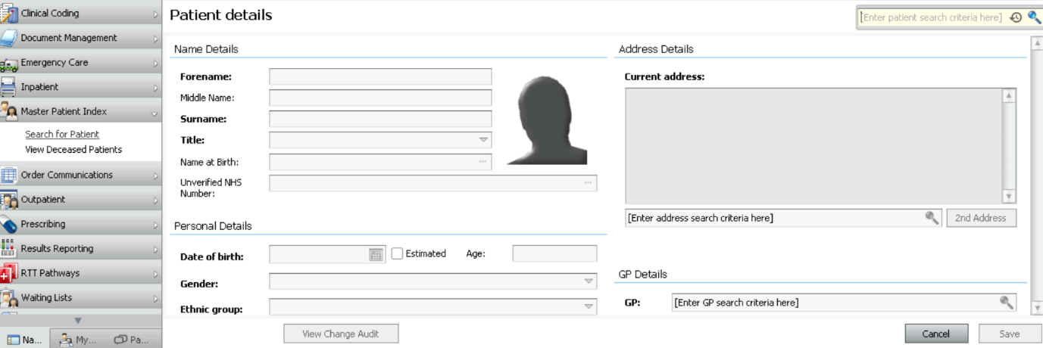

7. Open patient electronic care record.

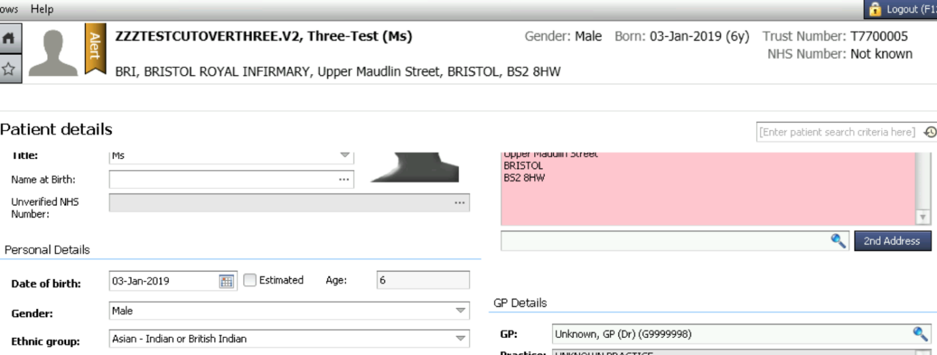

8, Click on Patient Info tab (first tab on L)
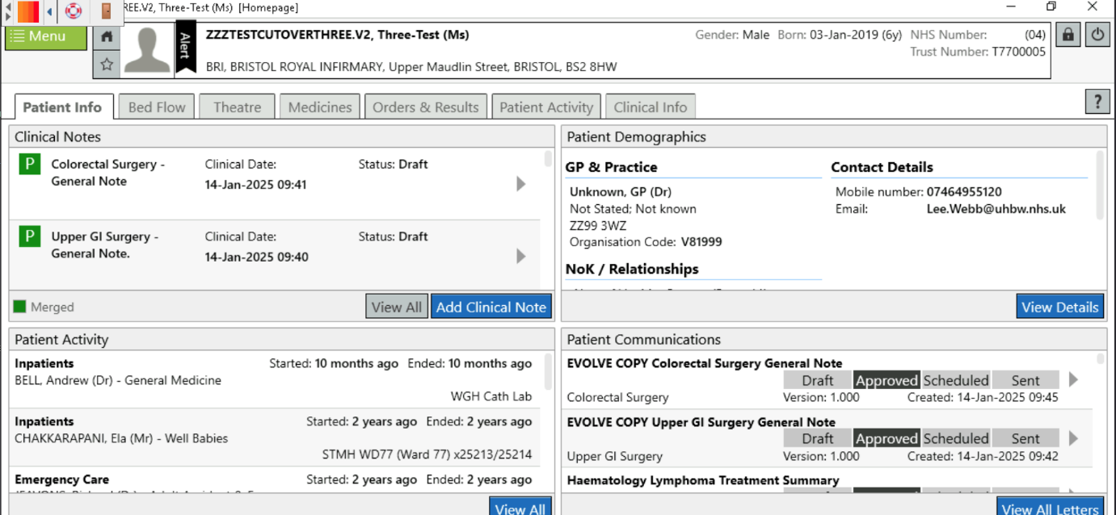
9. Click on Add Clinical Note in the Clinical Notes box (upper left quadrant)
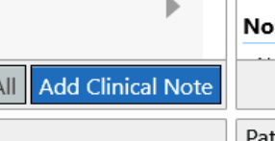
10. Use BRHC CED - External Referral template (save as favourite - yellow star)
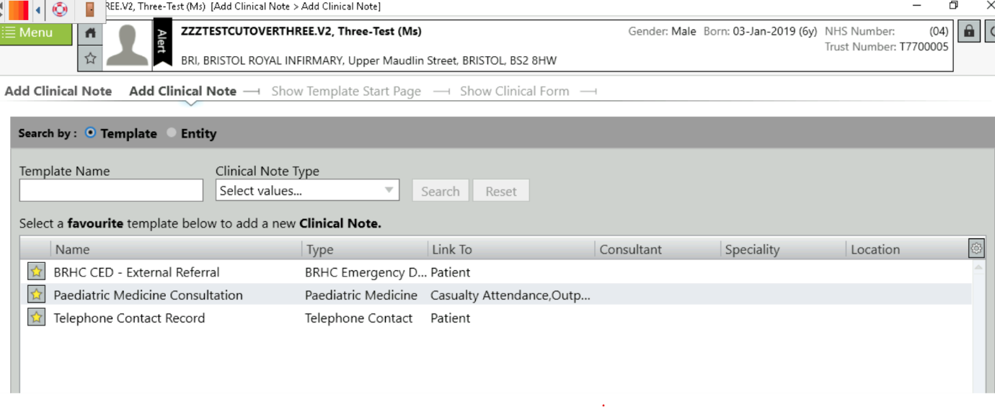
11. Check Date and Time

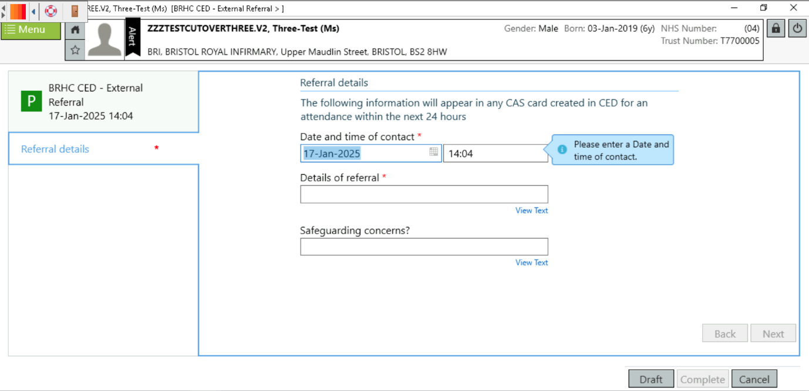

12.
COPY and Paste Adastra notes into Details of Referral.

13. Complete Safeguarding box as required. Follow Local Safeguarding policies and guidelines in your management. Verbally handover to the Nurse in Charge in CED any cases where safeguarding concern - call 0117 3428207 to handover.

14. Complete note.
