SESUI: Clinician User Guide

BrisDoc's new Telephony platform

Accessing
The desktop application should auto load on screen when you log into your computer account. If the application does not auto load, launch the application from the desktop.
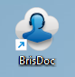

Prior to logging in all users must ensure their hardwired USB headsets are connected and working.

When ready to be used, you will be presented with the following login.
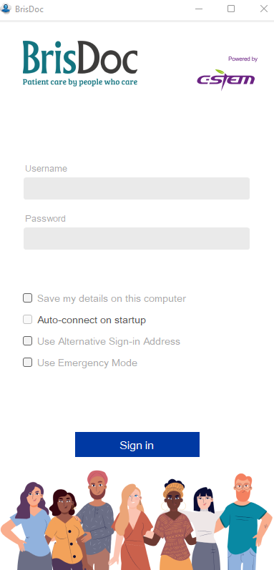

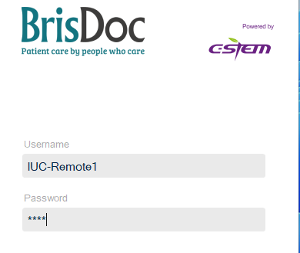
- Your Username will be assigned to you working by the shift manager
(Named accounts may be provided to Osprey staff or key operational roles such as Clinical Co-ordinator or Shift Manager)
- Your Pin will be 4 digits long.
- Please Do Not Tick the save my credentials box

Once you’ve entered your details click ‘SIGN IN’
The application will look like the below image for Clinicians
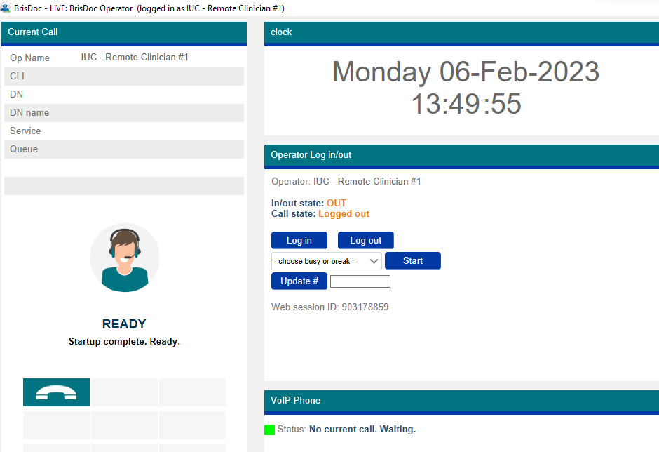
Next, click Log In button, you are now able to make calls through the application.

As the application loads if you see the following pop up message. Let this run until it has completely its connection. This will disappear automatically once ready.
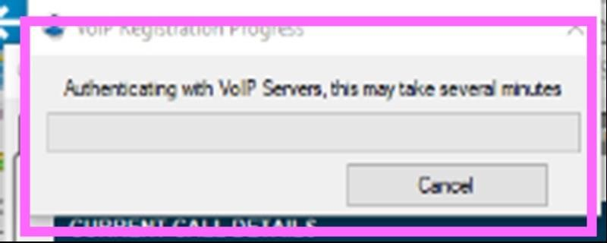

Adjusting Audio Settings
Before starting it is recommended that the Audio settings are checked and adjusted if needed, this is accessed by right clicking in-between the current call and the clock:
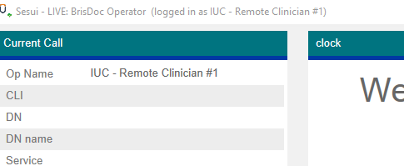

The following box will appear: Select Voip Set up
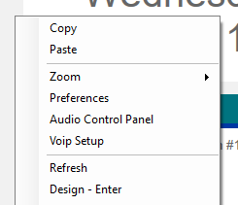
Ensure the Mic setting is at 100 and the speakers setting is at 80, by sliding the blue tab

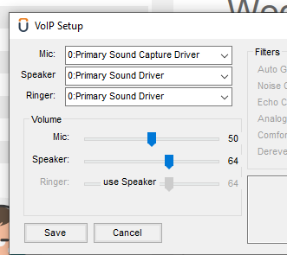
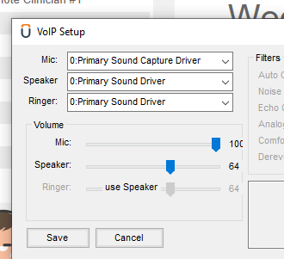
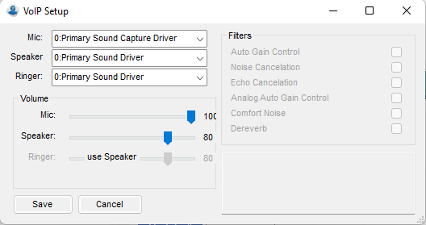
Save all changes

Making Outbound Calls
To make a call, click the green call button and numbers to call.
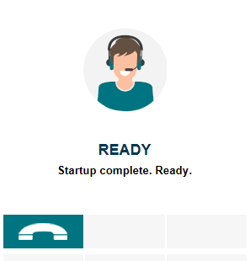

A grey box like this will pop up with available operators and numbers to call.
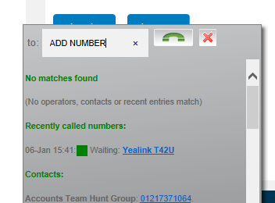
Add the number you want to dial, either by typing or copy and paste and then click the green button to start the call.
Numbers can be entered with or without a space 01179370001 or 0117 9370001
This Grey box also functions as an address book that is searchable, simply starting typing the name of the contact or the phone number into the grey box and the section will auto populate with matches. Note: You cannot call Operators that are not logged in.
Your phone will then ring to initiate the call.

Hang up – Terminates the call for all parties



HOLD - Places the call on hold. The patient will not hear you, and you will hear a holding beep tone. When this is activated the HOLD button will change to a RESUME, this will return your call back to the patient
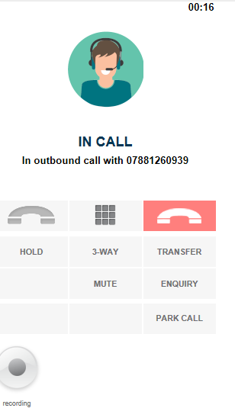
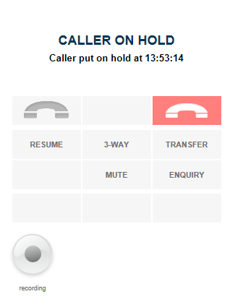

SELECTING MENU OPTIONS WHEN IN A CALL – Press the keypad option 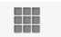the correct option can then be pressed from the keypad.

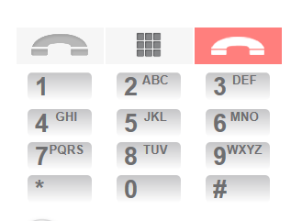

All Calls within Sesui are recorded

BUSY/BREAK Function
Please use the busy or break function as appropriate when you are unavailable to make or receive calls. This is accessed by changing the status in the busy or break box and selecting the correct option:
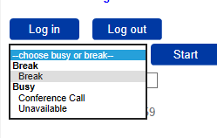
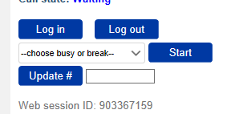

Next select Start break/busy
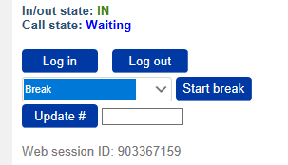

Your Status is updated: this will prevent Sesui ringing with any inbound calls and shows other users you are unavailable
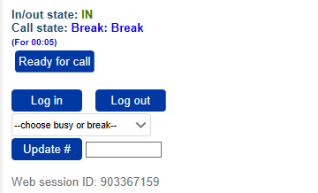

When you are ready to resume the session press Ready for Call

Logging Out and Closing Application
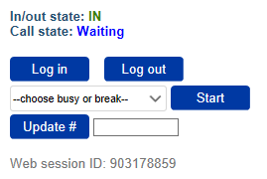
At the end of your shift, you can click log out, and then click the X in the corner to close your application.

Quick Fixes & Troubleshooting

- Outdialler calls are not allowed whilst the operator is logged out
If you see the following message:
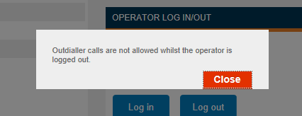
Fix: You have signed in but not logged in, press the log in button

- Our System shows that you are already signed in, or recently and unexpectedly signed out when logging in and someone else is logged in please call the shift manager.
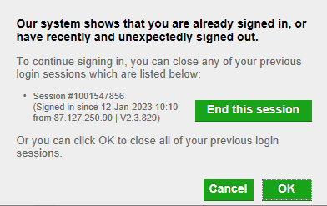

Fix: Contact the shift manager

- Your session has been ended
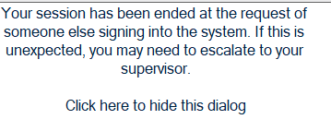
Fix: Contact Shift Manager

- The application failed to register with your chosen audio device.
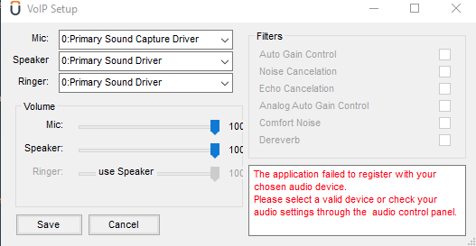
Fix: Log out, plug in USB headphones and then log back in.

- Caller cannot hear me or states it is hard to hear me
Fix: follow the adjusting the audio settings detailed previously

- Number not recognised
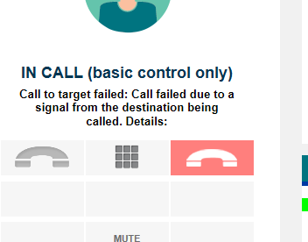
Fix: Check the number entered/ re-dial

- Unable to see system in full screen/See Log In button
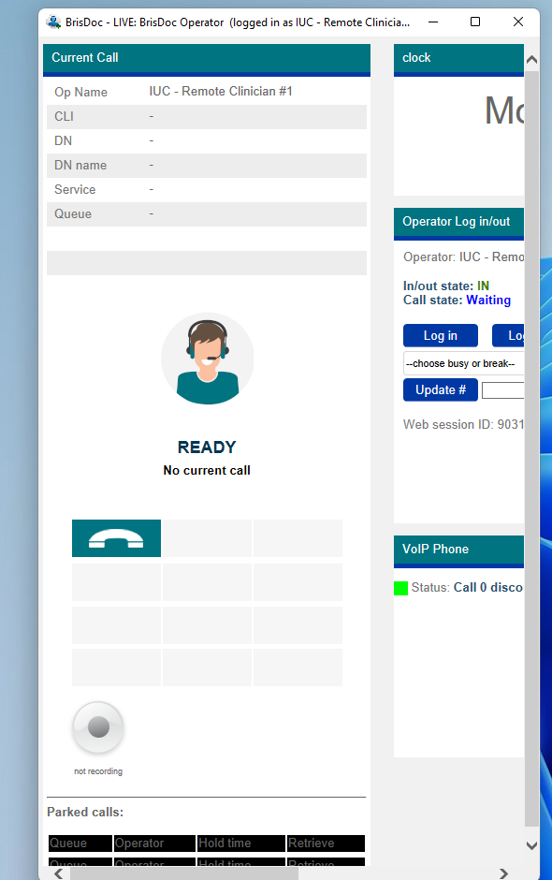
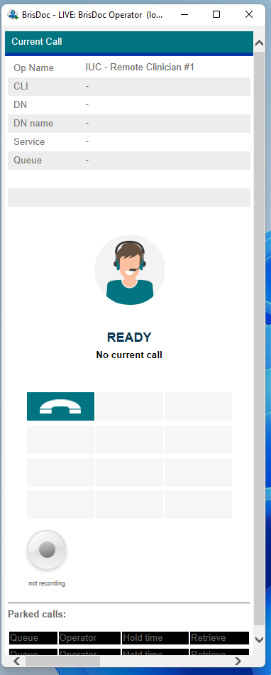

FIX: Expand the application

2. What happens if I enter the incorrect log in details?
The application will log out after 6 incorrect attempts.

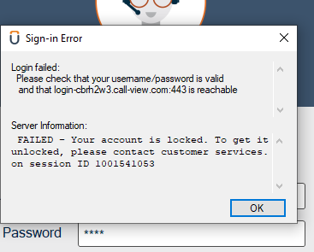
FIX: Call Shift Manager

